


Table of Contents
2
Abstract 3
Communication Systems 3
Frequency Ranges 5
LAB Transmitter Board and Other Measurement Equipment 5
Amplitude Modulation (AM) 7
Generation of DSB-AM 7
Frequency Modulation (FM) 13
Another experiment was done related to the FM signal. 16
Amplitude-shift keying (ASK) 17
Phase shift keying (PSK) 19
Frequency shift keying (FSK) 21
An example of binary FSK 22
Quadrature amplitude modulation (QAM) 24

Abstract
This report will theorize and understand the practical knowledge gained from the Topic Selected Topics in Communication Lab. This educational course/lab was established to cover many features and topics that were practically ambiguous from previous theoretical courses to shed more light on them to be clearer and easier to comprehend. The report's theoretical section will only explain, which will enable the students to gain quality understanding and knowledge from the stated course. On the practical or experimentation part, the information will reflect each learner's results from the experiments done. The communication Lab contains software and other valuable equipment that function together to convey advanced knowledge levels in Communication Systems in communication.

Communication Systems
In communication, modulation is defined as the process by which some characteristic of a carrier wave is varied following an information-bearing signal. In this case, a carrier wave is a high-frequency electromagnet wave modulated in amplitude or Frequency to convey a signal. The carrier is needed to facilitate the modulated signal's transportation across a band-pass channel from the transmitter to the receiver.
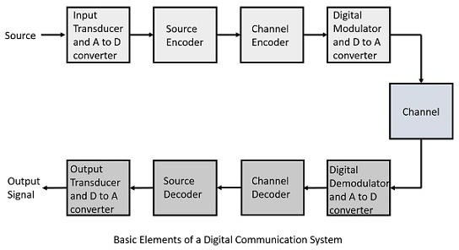

This transmission usually starts from the speaker, the voice signal passing through the transducer. Then we can get an electrical signal. The electrical signal processes across an electrical processor, after which it will be ready for transmitting as an electromagnetic wave signal. Therefore, the electromagnetic signal will reach a receiver translating the electromagnetic signal to an electronic signal. Across the transducer, the electronic password will be changed to be a familiar voice signal and ready for the ear.

Frequency Ranges
Frequency refers to the number of waves that pass a fixed place in a given amount of time. The usable Frequency in the Lab usually has a range of between a few kHz to many GHz.Depending on the application and due to the numerous attributes of electromagnetic waves, the waves with different wavelengths are used for message transmission. An example is the radio wave with an electromagnetic wave of a frequency of between 104 and 1011 or 1012 Hz, which is used for long-distance communication.

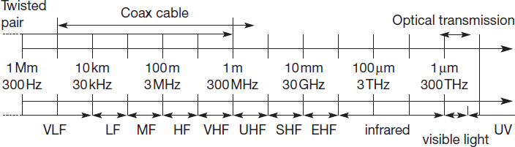

LAB Transmitter Board and Other Measurement Equipment
At the LAB, many components support learners in better understanding the different telecommunication technologies today.
One of the main components of the LAB is the experiment board. The experiment board is broken down into several functional units.
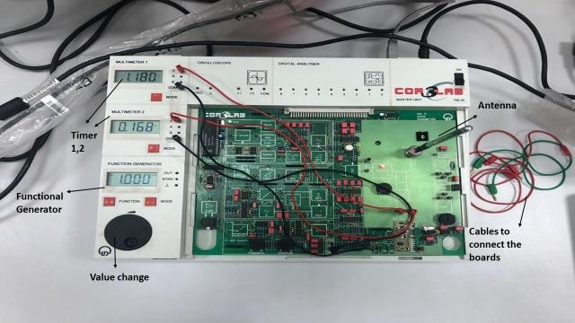

The first experiment in this course begins by using a simple transmission way.
1. First, a mobile phone is connected with a board through Bluetooth technology.
2. through the experiment board, the signal amplitudes.
3. After that, the signal is transmitted through the antenna. This applies in wireless communication
4. After the signal is transmitted, the 2nd experiment board received the password through another antenna (receiver).
5. Finally, The 2nd board has a decoder for decoding the signal and making it normal to be presented through the speaker.
Essential pieces of measurement equipment used in transmission technology:
- Oscilloscope
- Frequency counter
- Spectrum analyzer
- Network analyzer
- Reflect meter
- SWR meter.

Amplitude Modulation (AM)
Modulation is used to refer to how some characteristics of a carrier wave are varied in following an information-carrying signal. This definition is the one commonly used in the communication domain. In simple terms, AM is a modulation method used in electronic communication. Amplitude modulation is most commonly used for transmitting messages with a radio carrier wave. In amplitude modulation, the amplitude, which is the carrier wave's signal strength, is varied in proportion to that of the message signal, such as an audio signal. Good signal strength will translate to a clearer audio signal.
Amplitude modulation was among the earliest modulation method used for transmitting audio in radio broadcasting. AM was established during the first quarter of the 20th century. Some of its proponents were Roberto Landell De Moura and Reginald Fessenden's who did radiotelephone experiments in 1900.

Generation of DSB-AM
In the following experiment, the multiplication of 2 oscillations is investigated using the time and frequency domain.
- Carrier 10 kHz.
- Variable SineSine.
- Wave from the function generator.
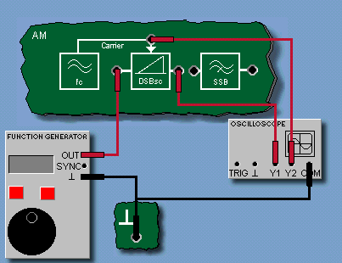

- First, the function generator should be connected to the oscilloscope following the circuit diagram and then set the function generator to DC, 1 V.
- Open the oscilloscope and measure the amplitudes of Y1 and Y2. After that, Calculate the modulation coefficients kM and enter the result into the appropriate field as the modulator's left input is biased with 1 V DC.
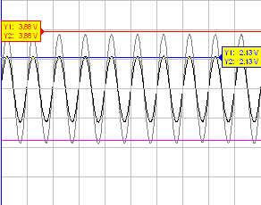

- Set the function generator to Sine, 20 Hz, 10 Vpp. Open the oscilloscope and adjust the settings to view the curve (X/div = 0.5 ms), as shown in the diagram below.
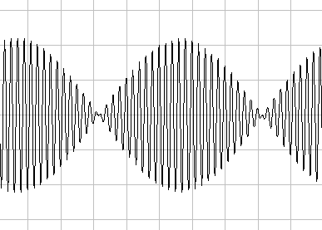
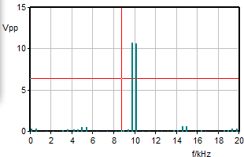

- Increase the function generator's Frequency up to 4 kHz in several steps and observe the changes in the curve displayed on the oscilloscope.
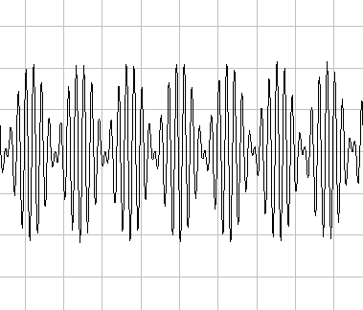
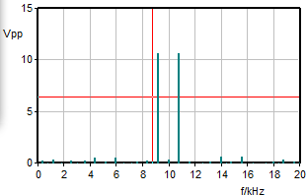

Frequency (780 Hz)

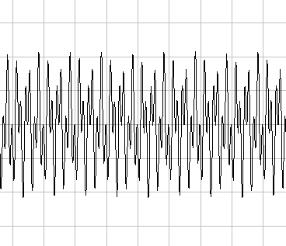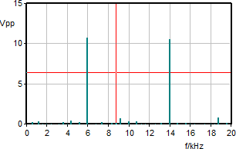
Frequency (4000 Hz)

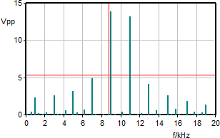
- Next, set the function generator's Frequency to 1 kHz and change the signal shape one after the other to Triangular and Square-wave.
- Remove the connection to the function generator and use a connecting lead to connect the Carrier socket to the modulator's input. Observation of the signal of the oscilloscope should be done first and then the FFT module.

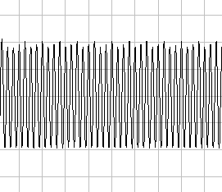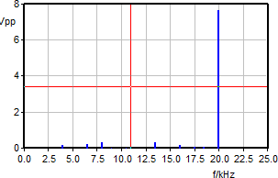

- After that, connect the circuit as shown in the circuit diagram—AM transmitted carrier (full AM).
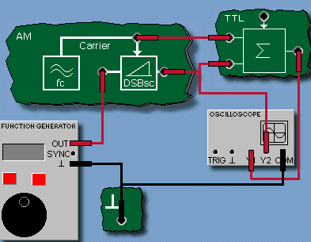

- After connecting the circuit, set the function generator to SineSine, 1 kHz, 10 Vpp, DC = 0 V. Open the oscilloscope and adjust it for the curve characteristic to be displayed (X/div = 0.5 ms).
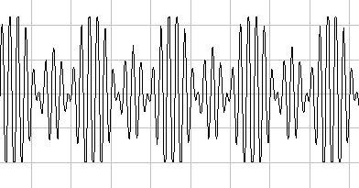
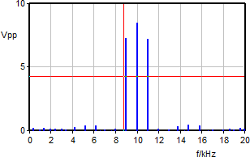

- Another step is to randomly vary the function generator's frequency setting between 500 Hz and 2000 Hz and set the amplitude between 0 Vpp and 10 Vpp.

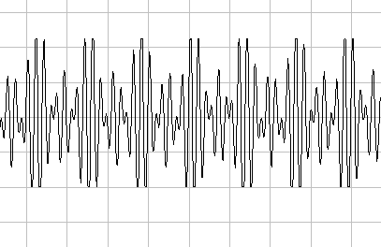
F=500Hz, V=10 Vpp

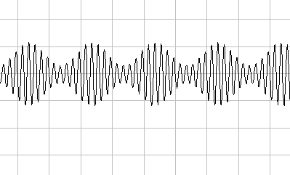

F=1000Hz, V=2 Vpp
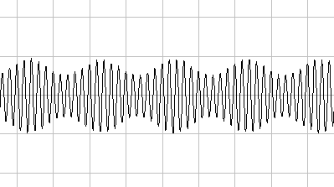
F=2000Hz, V=2 Vpp

- Remove the carrier's connection and the summation stage's upper input, as shown in the circuit diagram. After doing this, the carrier should vanish from the spectrum. Increase the DC component slowly to approximately DC = 2 V on the function generator. Increasing the component will, in turn, enable the carrier to reappear in the output signal.
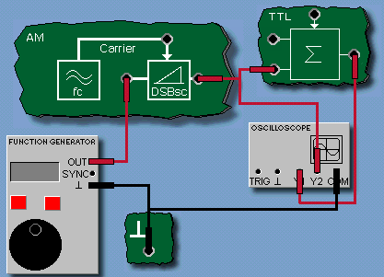

Frequency Modulation (FM)
Frequency modulation is defined as encoding information in a carrier wave and is done by varying the wave's instantaneous Frequency. In simple terms, FM can refer to varying the Frequency of the carrier signal linearly with the message signal. The technology of frequency modulation is used in telecommunications, radio broadcasting, and signal processing. Frequency modulation (FM) and phase modulation (PM) form the angular modulation method, which is based on altering the Frequency of a carrier signal to encode the message signal. Normally, FM modulators are designed as voltage-controlled oscillators (VCOs).
The following experiment is used to record the static characteristic of the VCO. This depends on the middle frequency presetting using Frequency. The Amplitude controller is used to set the amplitude of the VCO output signal.
- According to the Figure below, the function generator and the oscilloscope are connected to the experiment board. Set the function generator initially to DC = 0 V.
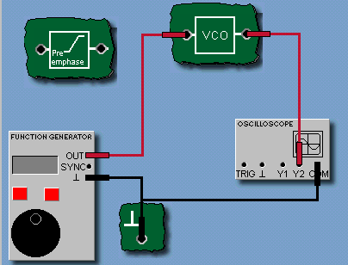

- Open the frequency counter, and in the operating panel of the frequency counter, set the Trigger to +Y2. Turn the Amplitude potentiometer to the far-right and stop at maximum. After that, set the Frequency potentiometer so that there is a frequency of approximately 10 kHz at the output.
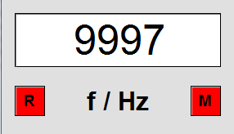

- A DC voltage of -10 V should be set on the function generator. Then, open the characteristics plotter and enter the value pair (U, f) into its Table. Increase the voltage at the VCO input in steps of 2.5 V until you reach 10 V and enter the measured value pairs into the Table. Set the voltage at the information to 0 V after entering the measured values.
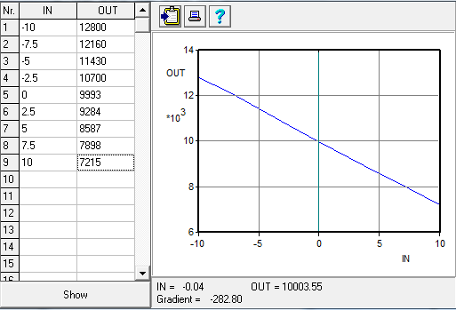

- Determining the modulation coefficient k in the region around Uin = 0 V is done based on the characteristic slope using the markers of the characteristics plotter to accomplish the task. Enter the result in the appropriate field. Make sure to note down the correct sign that is K=-282.8.

Another experiment was done related to the FM signal.
- Connect the function generator and the oscilloscope to the experiment board as done in previous experiments and initially set the function generator to DC = 0 V.
- Other than the oscilloscope, open the FFT module and set it to Y1, f max=20 kHz. Start the measurement.
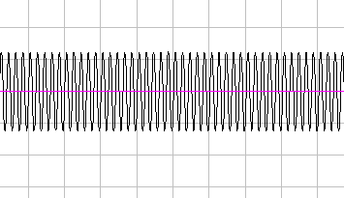
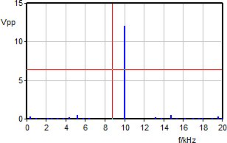

Input voltage=0 v DC

Amplitude-shift keying (ASK)
An amplitude shift key is amplitude modulation representing digital data as variations in a carrier wave's amplitude. In an ASK system, the binary symbol is usually represented by transmitting a fixed-amplitude carrier wave and fixed Frequency for a bit of T seconds. It has a digital signal that is represented by 0 and 1 digits. If the signal value is 1, then the carrier signal will be mailed; or else, a signal value of 0 will be sent. ASK usually functions by assigning bit values to discrete amplitude values that in turn transmit information.
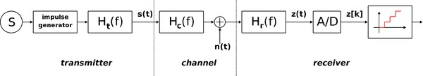
ASK diagram
ASK system has three divisions; the first one represents the transmitter; the second one is a linear model of the channel's effects, while the third division shows the receiver's structure. The following notations are used in the ASK system:

- ht(f) denotes the carrier signal for the transmission
- hc(f) denotes the impulse response of the channel
- n(t) stands for the noise introduced by the channel
- hr(f) is the filter at the receiver
- L is the number of levels that are used for transmission
- Ts is the time between the generation of two symbols
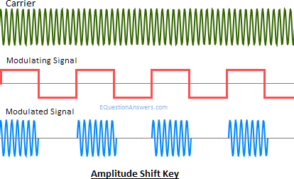

Phase shift keying (PSK)
The digital modulation process that conveys data by changing or modulating the constant frequency reference signal (the carrier wave) is referred to as phase shift keying. The modulation process is accomplished by varying the sine and cosine inputs at a precise time. For instance, to calculate the phase shift, when an electronic oscillator produces sine waves at a frequency of 100 Hz, by dividing the Frequency into one you can get the duration of each cycle case is 0.01 seconds. It is commonly used for wireless Local Area Networks, Radio Frequency Identification, and Bluetooth communication.
In addition to the advantages found in FSK, PSK also benefits from a higher immunity to interference. The AM modulator's PSK signal is produced in conjunction with a pure AC signal in the following experiment. The PSK spectrum corresponds to that of a double sideband suppressed amplitude modulation (DSB-AM) call without a carrier.
- Connect the function generator to the oscilloscope, as specified in the circuit diagram.

- The next step is to set the function generator to curve shape square-wave, Frequency 1 kHz, amplitude 4 Vpp, 0 V DC, pulse duty cycle 50%.
- Open the oscilloscope and make the following settings: Curve Dual, X/div 100 μs, Y1/div = Y2/div = 5 V, Trigger Off. After the setting, begin the measurements.
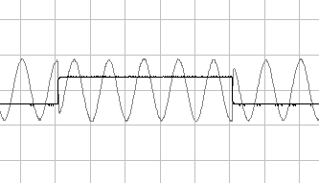
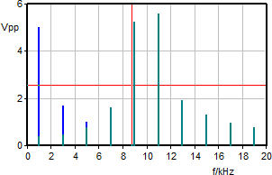
- Also, open the FFT module and set it to Y2, fax = 20 kHz and then start the measuring.

Frequency shift keying (FSK)
This is a Frequency modulation technique in which digital information is transmitted through discrete frequency changes of a carrier signal. This means that the carrier signal varies according to the digital signal. The (binary) FSK transmits data at the discrete frequencies f1 and f2. Any lack of transmission signal must automatically be attributed to faulty or defective transmission. FSK represents a particular case of FM transmission. Due to this, it has a correspondingly expanded and complex spectrum. FSK is the preferred form of data transmission via the telephone system using modems because the output is high in Frequency. Regarding modems, a distinction is drawn between the following operating modes:
- Simplex
- Duplex
- Half-duplex
The simplest FSK is binary FSK (BFSK). BFSK uses a couple of discrete frequencies to transmit binary (0s and 1s) information. 1s and 0s are referred to as mark and space frequencies, respectively.
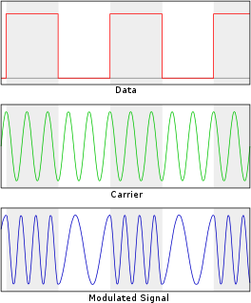

An example of binary FSK
A binary FSK signal's demodulation can be done using the Goertzel algorithm, which is very efficient and can be used on low-power microcontrollers. The Goertzel algorithm is a digital signal processing (DSP) distinct for efficient evaluations of the individual terms of the discrete Fourier transform (DFT).
It is useful for indefinite practical applications such as recognizing dual-tone multi-frequency signaling (DTMF) tones produced by the keypad's push buttons of a traditional analog telephone.

- In the experiment, connect the function generator G1 and the oscilloscope to the experiment board, as shown in the illustration above. First, set the function generator to DC = 0 V.

- Open the frequency counter. In the operating panel of the frequency counter, set Trigger to Y2. Turn the Amplitude potentiometer to the right far limit and Set the Frequency potentiometer so that it is approximately. 10 kHz is applied to the output.
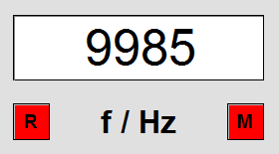

- The next step is to set the function generator in the following format.: square-wave, 1 kHz, 20 Vpp, DC = 0
V. Open the oscilloscope and set It to: X/div = 200 μs, Y1/div = Y2/div = 5 V, Curve Dual, and Trigger Off and begin the measurement.
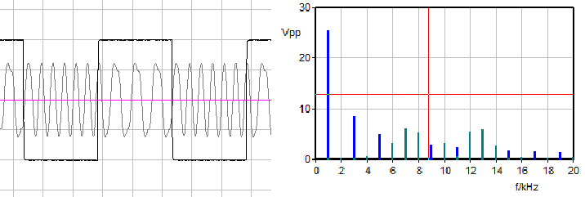
- In addition to the oscilloscope, open the FFT module, set it to Y2, f max = 20 kHz, and then start the measurement as illustrated below.

Quadrature amplitude modulation (QAM)
QAM belongs to the family of digital modulation methods and is related to analog modulation methods. These techniques are generally used in modern telecommunications to transmit information. It conveys two analog message signals, or two digital bit streams, by changing (modulating) the amplitudes of two carrier waves, using the amplitude-shift keying (ASK) digital modulation scheme or amplitude modulation (AM) analog modulation scheme. In simple terms, it combines signals into a single channel, thus doubling their effective bandwidth. Orthogonality or quadrature is the state through which two carrier waves of the same Frequency are out of phase by 90°. The two waves can be articulately separated (demodulated) because of their orthogonal property. Another fundamental property is that the modulations are low-frequency/low-bandwidth waveforms compared to the carrier frequency, known as the narrowband assumption.
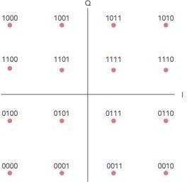
QAM is used broadly as a modulation system for digital telecommunication systems. These telecommunication systems include 802.11 Wi-Fi standards. High spectral efficiencies can be attained with QAM by setting a suitable constellation size, limited only by the communications channel's noise level and linearity. QAM is also used in optical fiber systems as bit rates increase; QAM-16 and QAM-64 are evolutions of the QAM family.
Bit sequence mapping for a 16QAM signal
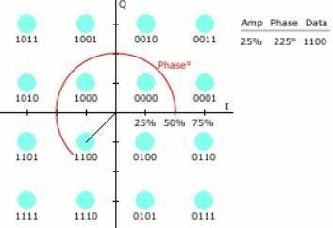
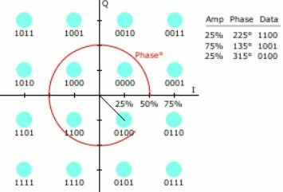
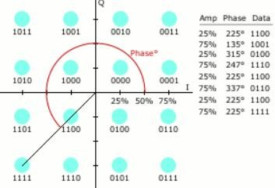
Digital 16-QAM with example constellation points

